Bradley Lowe
Chelsea Thompto
ART 2434
011 October 2026

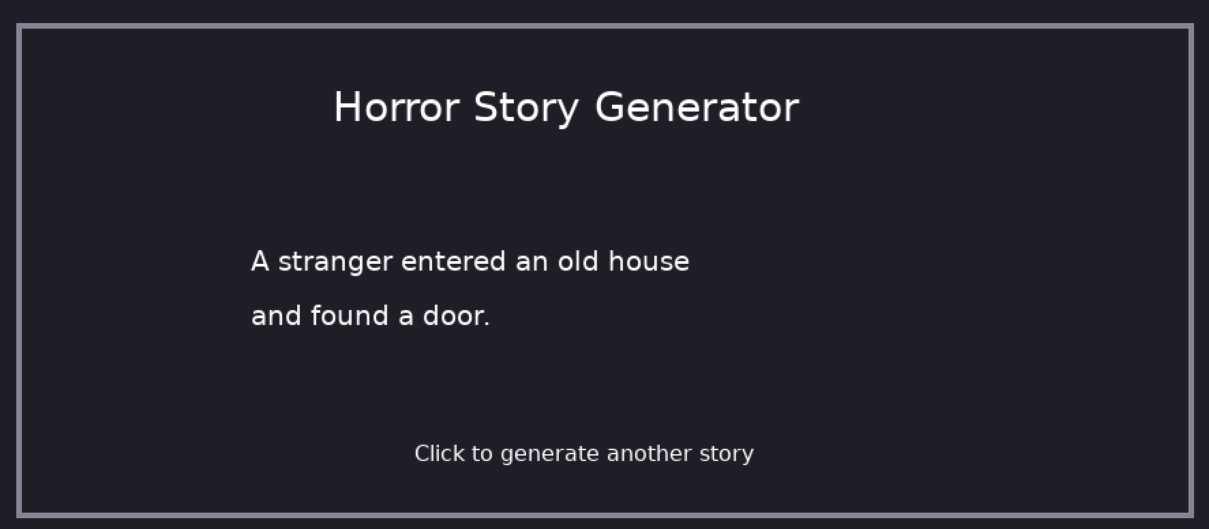

Placeholder.

Code for Homework 8:

-- Homework 8
-- Bradley Lowe

require("L5")

-- Horror story choices
characters = {"A stranger", "A ghost", "A detective", "A creature", "A lost traveler"}

locations = {"an old house", "a dark forest", "a rundown hospital", "a basement", "an unknown city"}

events = {"saw a figure", "found a door", "heard screaming", "followed footprints"}

function setup()
size(900, 400)

windowTitle("Horror Story Generator")
describe("Click the mouse to generate a random horror story")

textGenerator()
end

function draw()
end

-- Generate a random horror story
function textGenerator()
background(30, 30, 40)

-- Border around the window
noFill()
stroke(130, 130, 150)
strokeWeight(3)
rect(20, 20, 860, 360)
noStroke()

-- Title
fill(255)
textSize(30)
text("Horror Story Generator", 250, 90)

-- Pick random choices
local character = random(characters)
local location = random(locations)
local event = random(events)

-- Display the story
textSize(20)
text(character .. " entered " .. location, 190, 200)
text("and " .. event .. ".", 190, 240)

-- Instructions
textSize(16)
text("Click to generate another story", 310, 340)
end

-- Mouse controls
function mousePressed()
textGenerator()
end

